**Lab 2:**

**Second Order Circuit**

Name: Wan-Yu Liao

ECEN 325 Section 514

TA: Mandela

Lab Date: September 13, 2019

Report Due Date: September 16, 2019

**Calculation**

There are 3 circuits, Circuit a (Low-pass circuit), Circuit b (High-pass circuit), Circuit c (Band-pass circuit). For each circuit, I first derived the transfer function and calculated the values for each resistors and capacitors. Then I sketched the Bode plot and calculated the output voltage given input voltage = 0.5sin(2π6000t).

**Circuit a.**

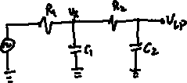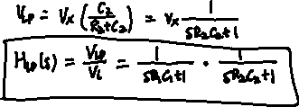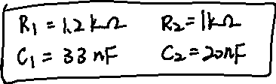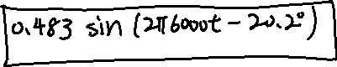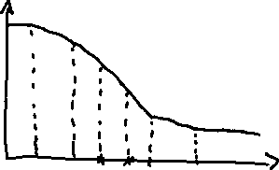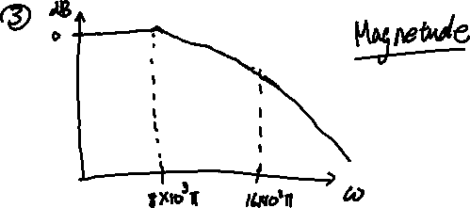

**Circuit b.**

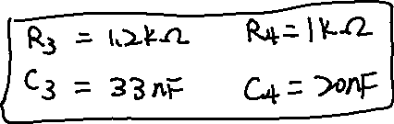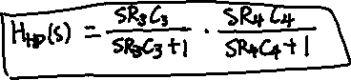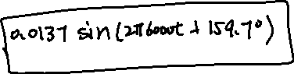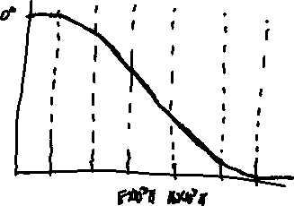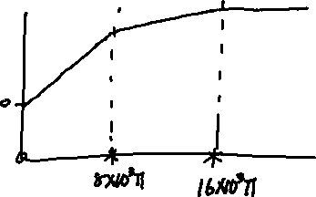

**Circuit c.**

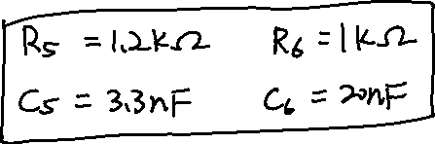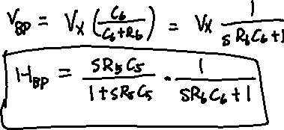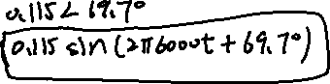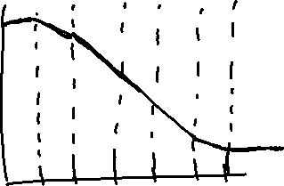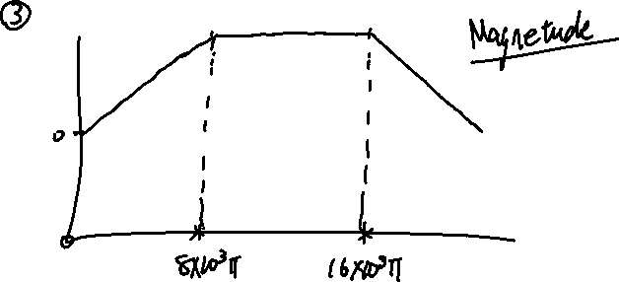

**Simulation Plots**

**Circuit a.**

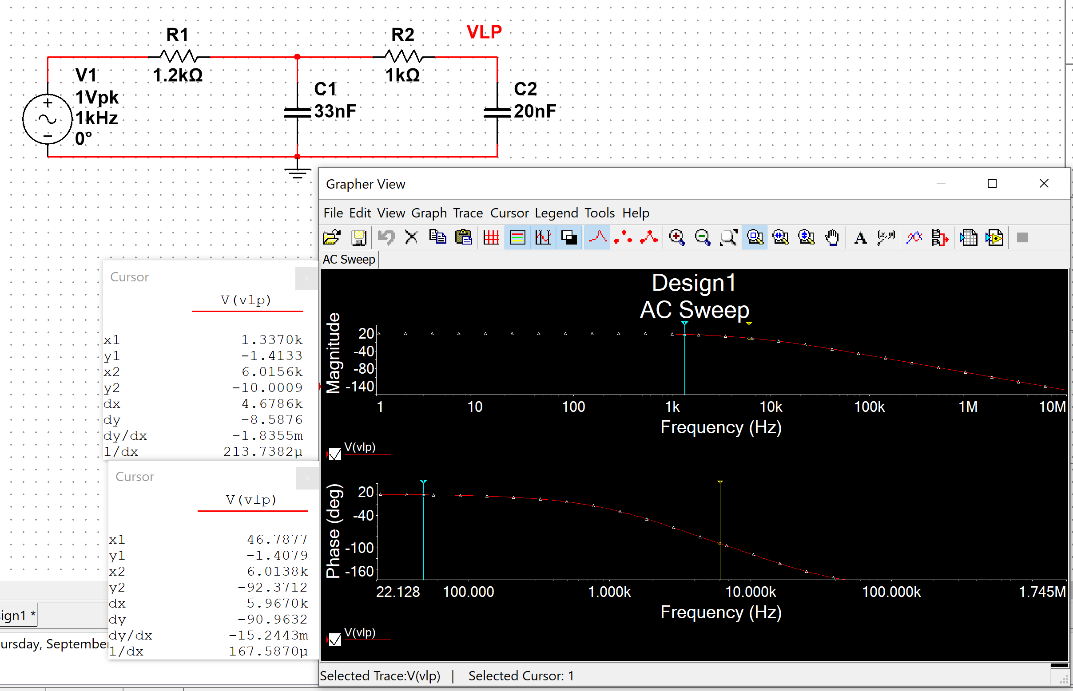

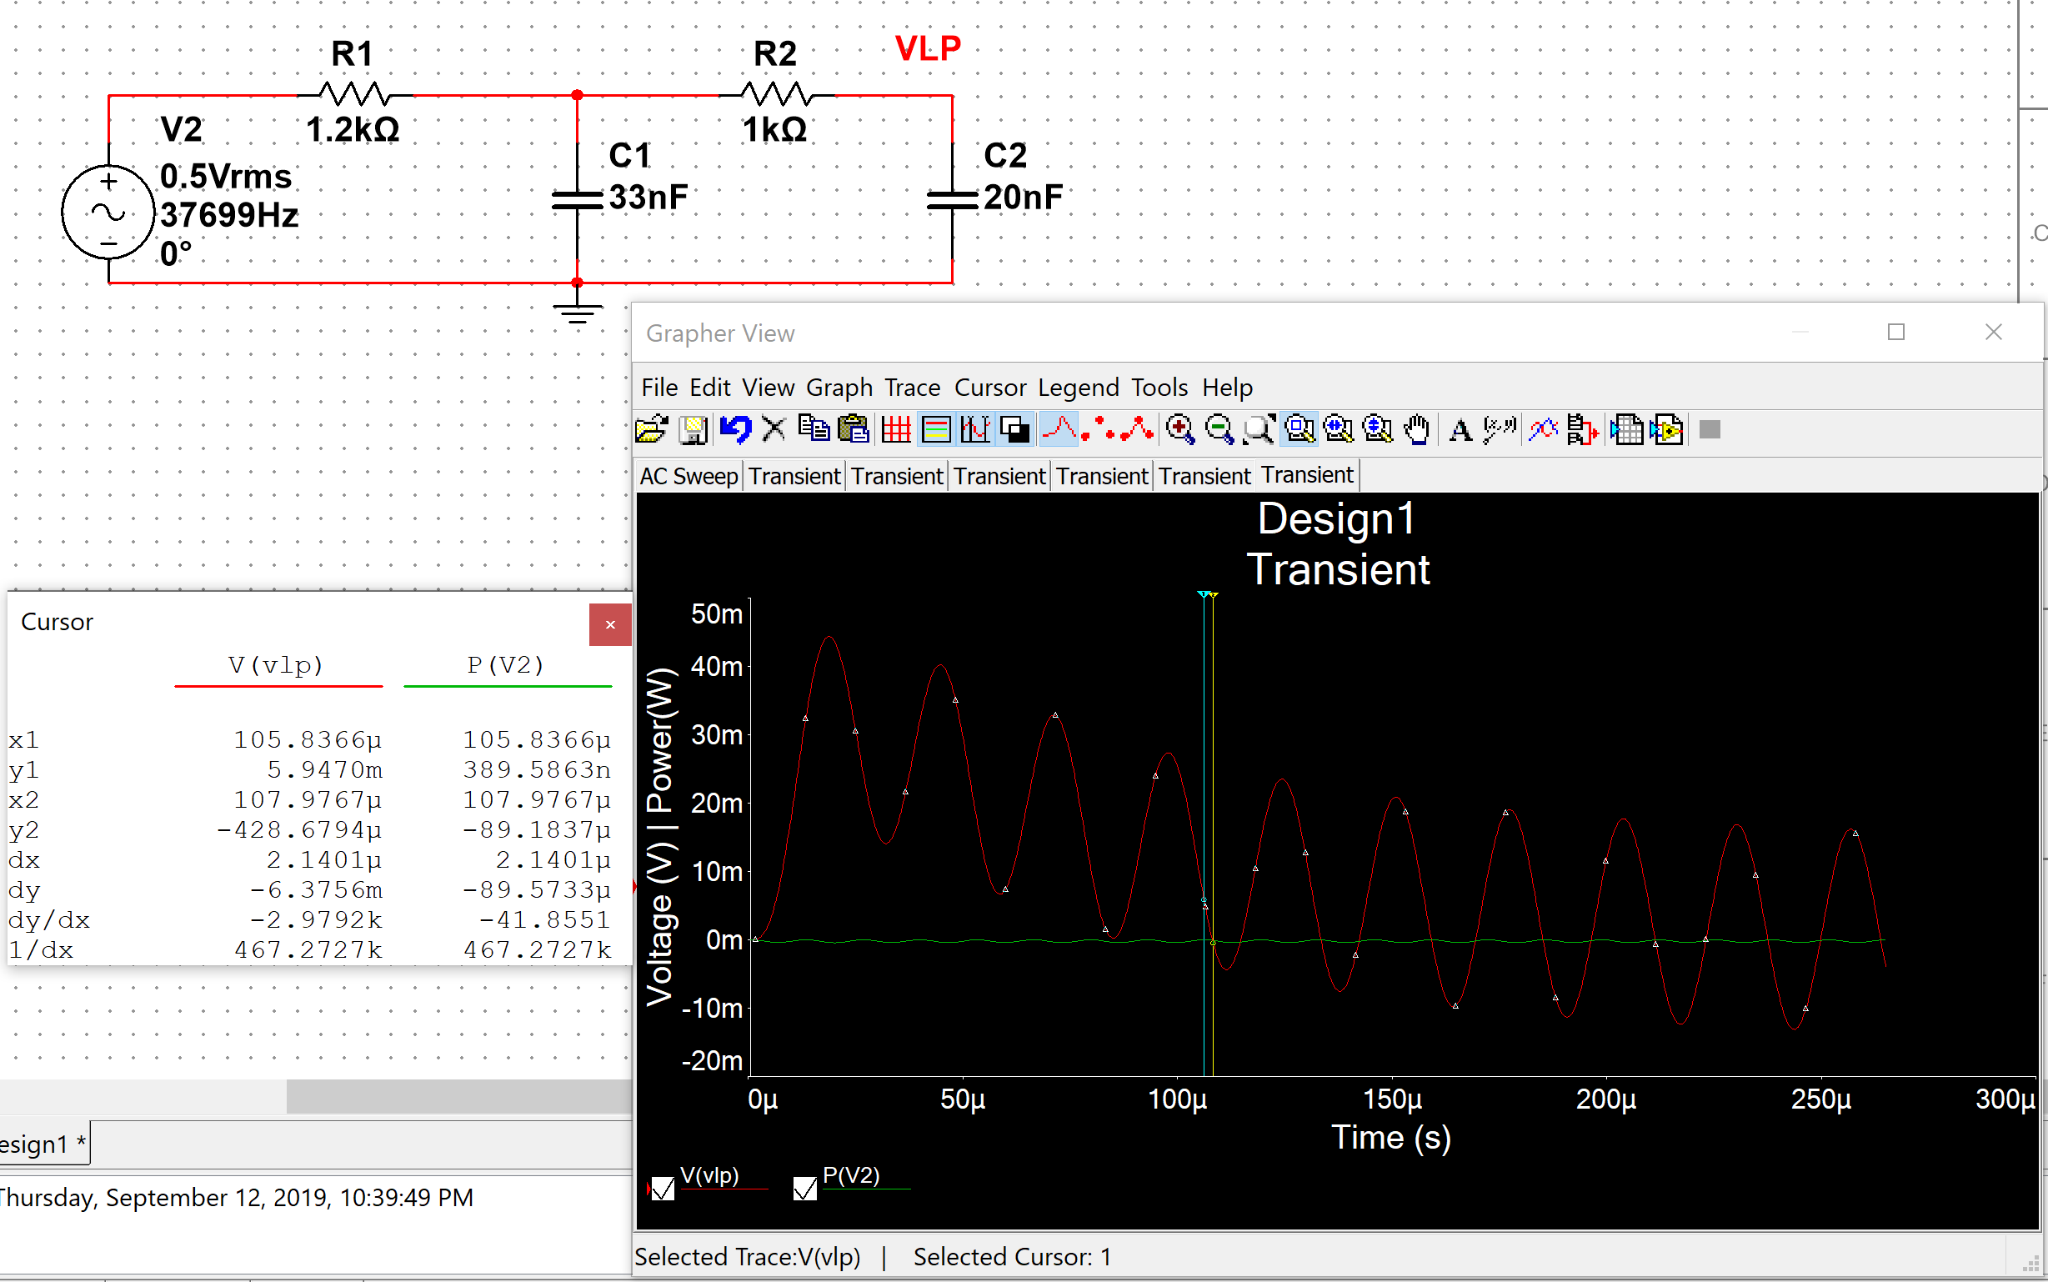

**Circuit b.**

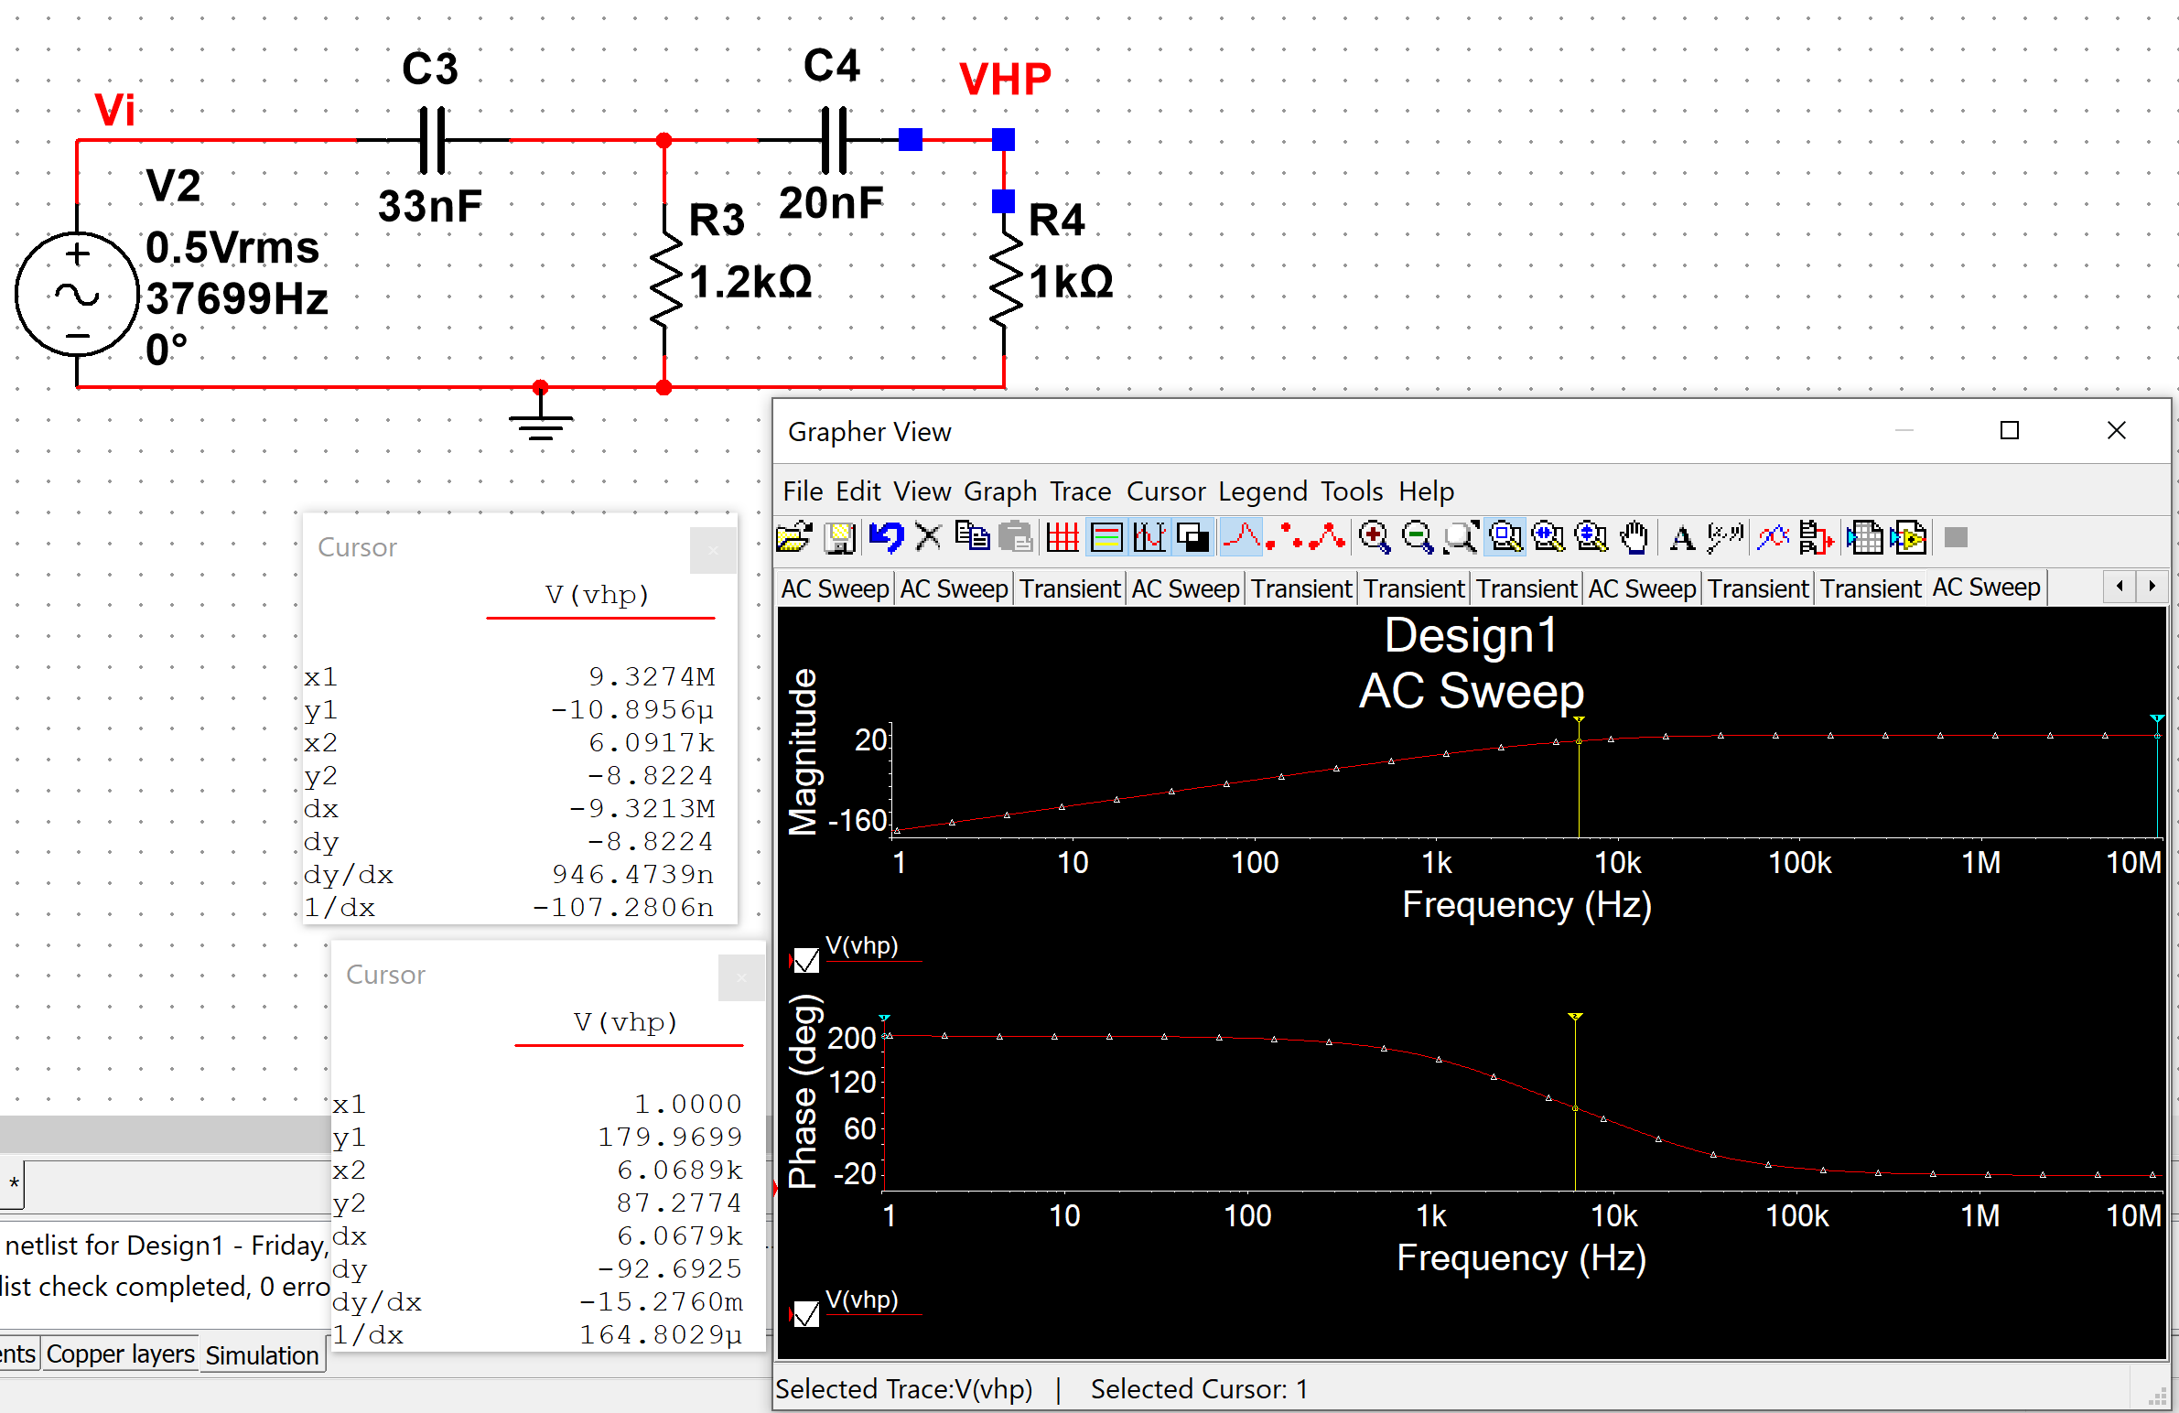

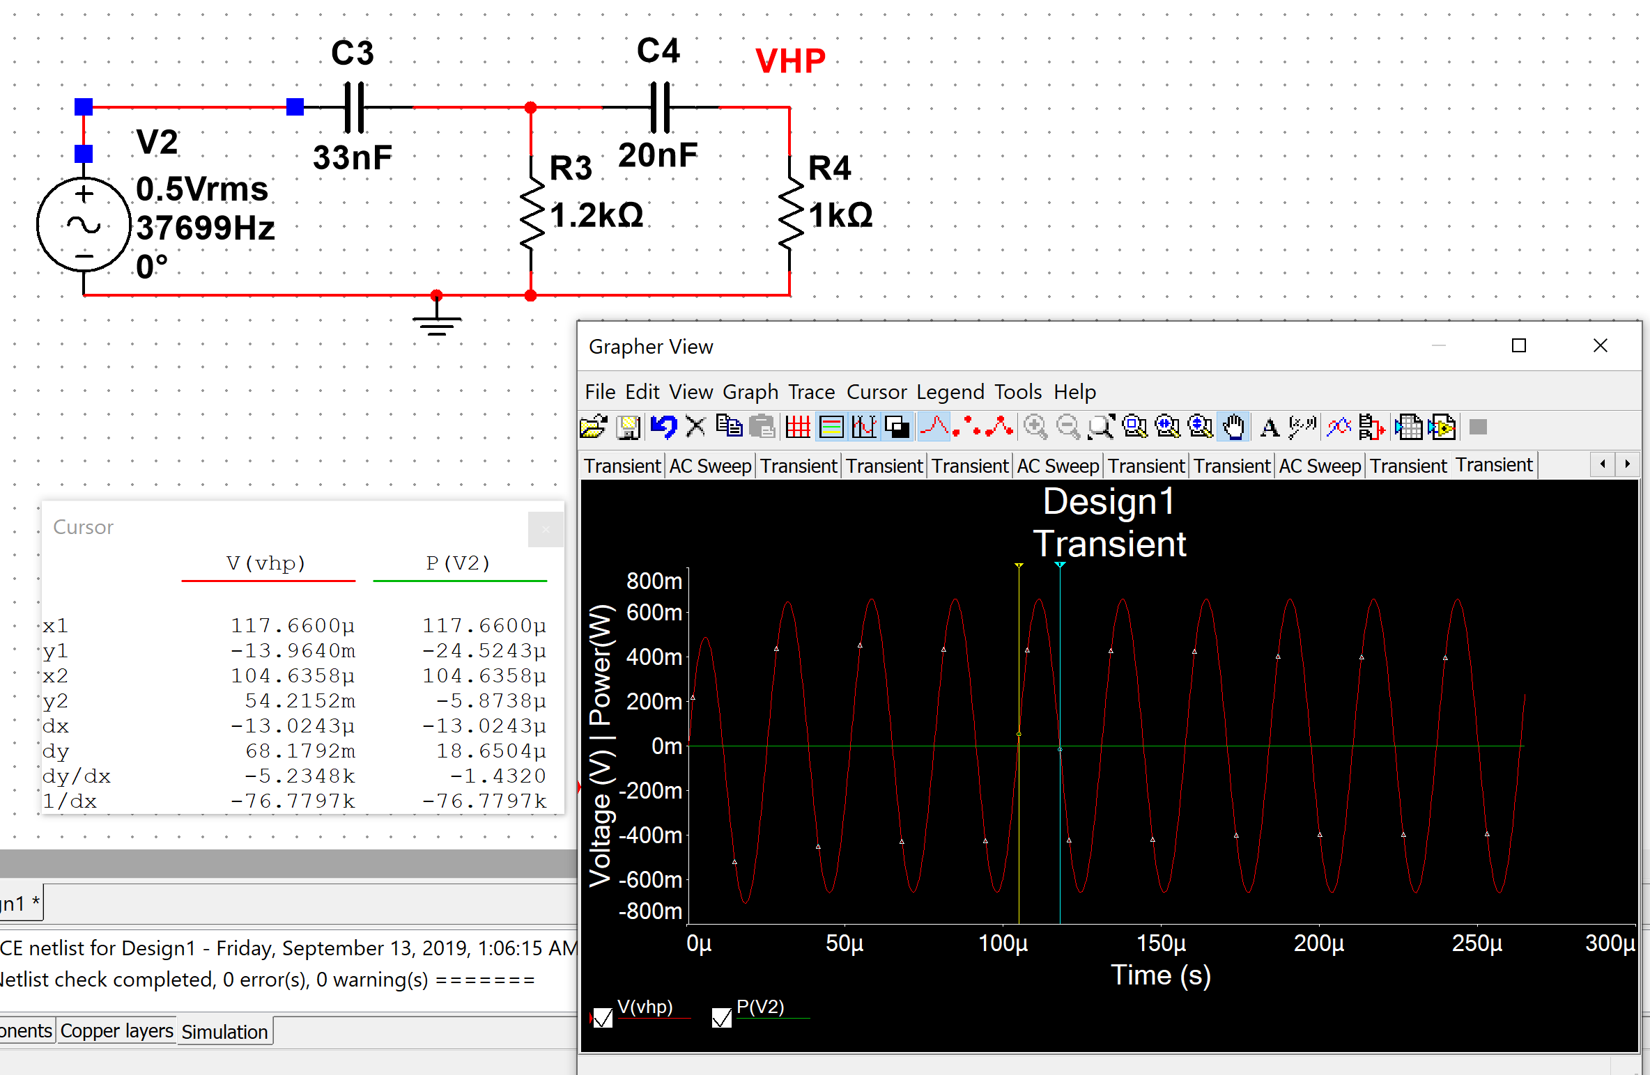

**Circuit c.**

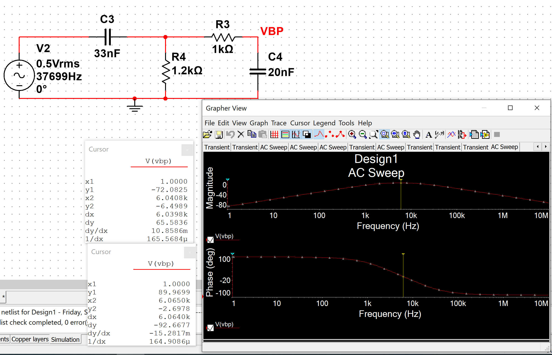

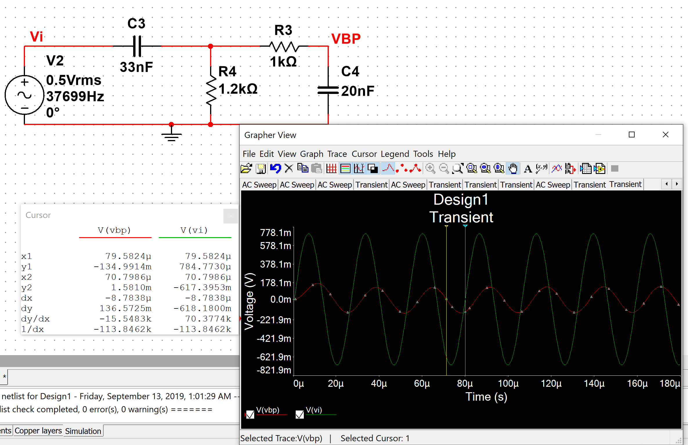

**Measurement Plots**

**Circuit a.**

**Circuit a – Bode Plot**

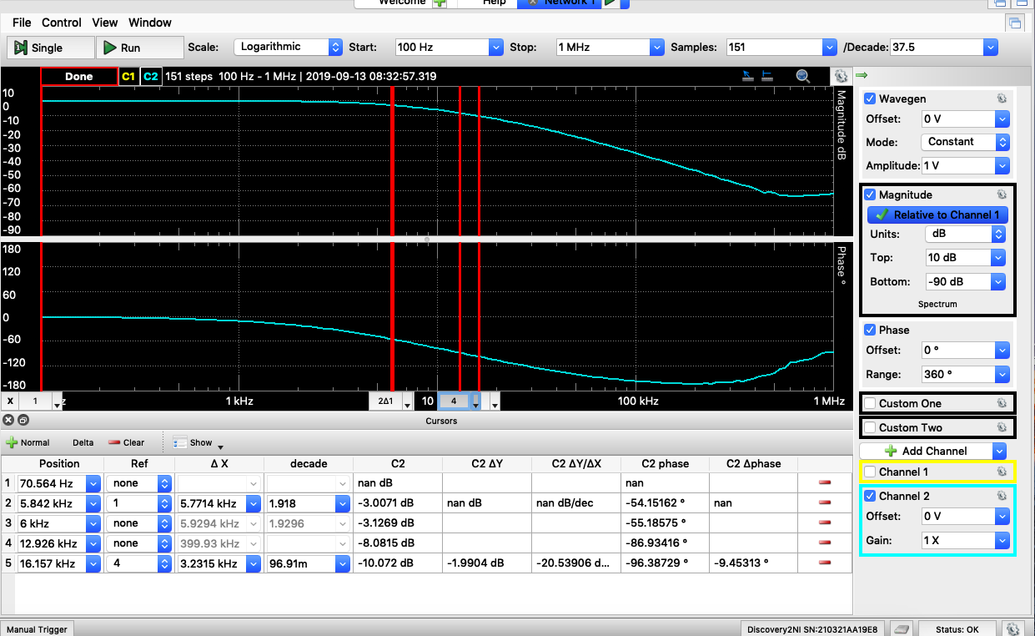

**Circuit a – Time Domain Plot**

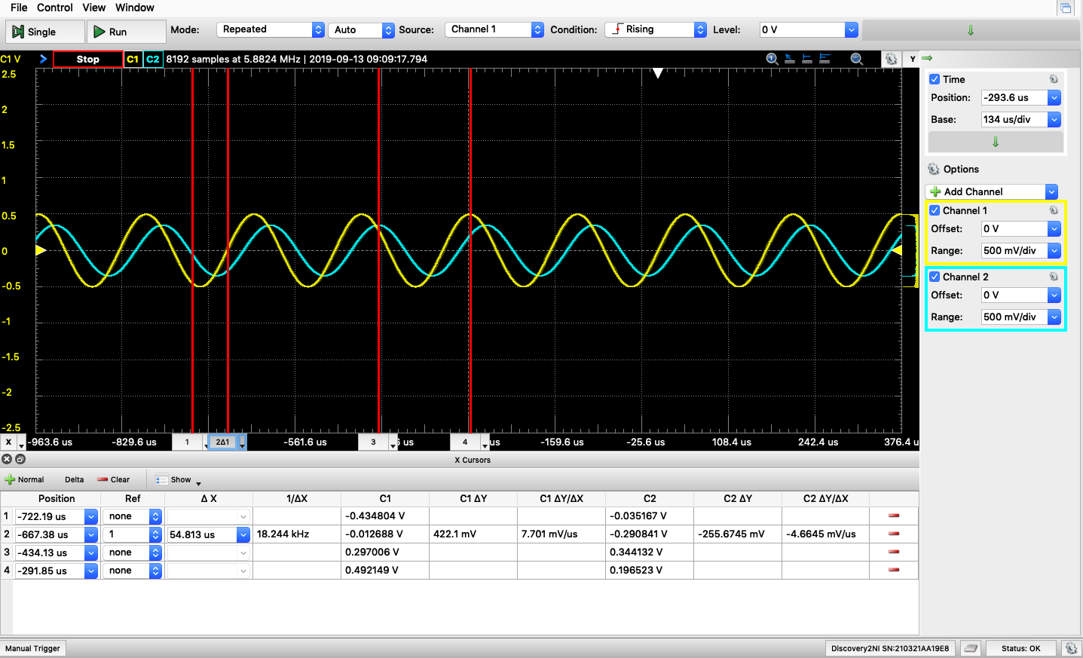

**Circuit b.**

**Circuit b -Bode Plot**

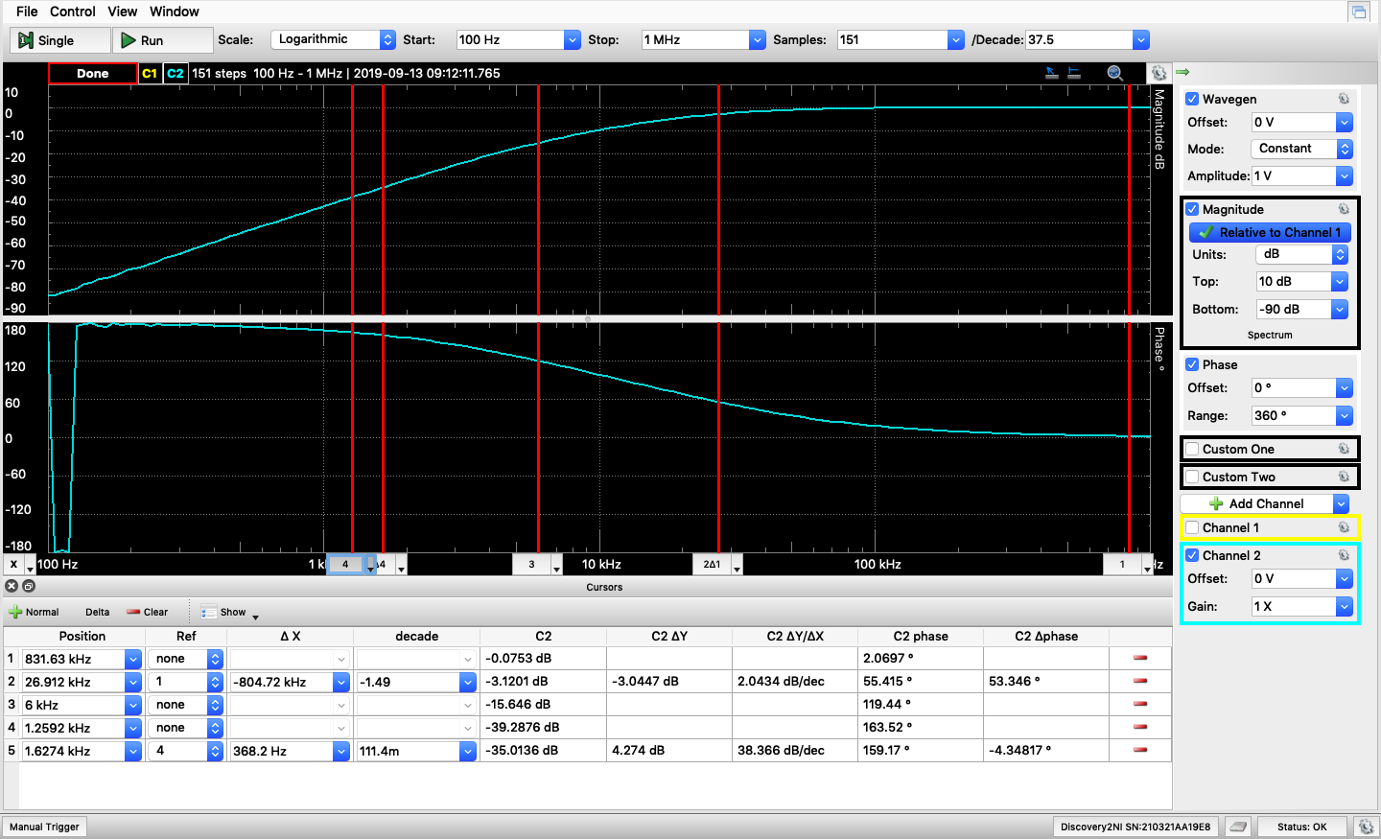

**Circuit b – Time Domain Plot**

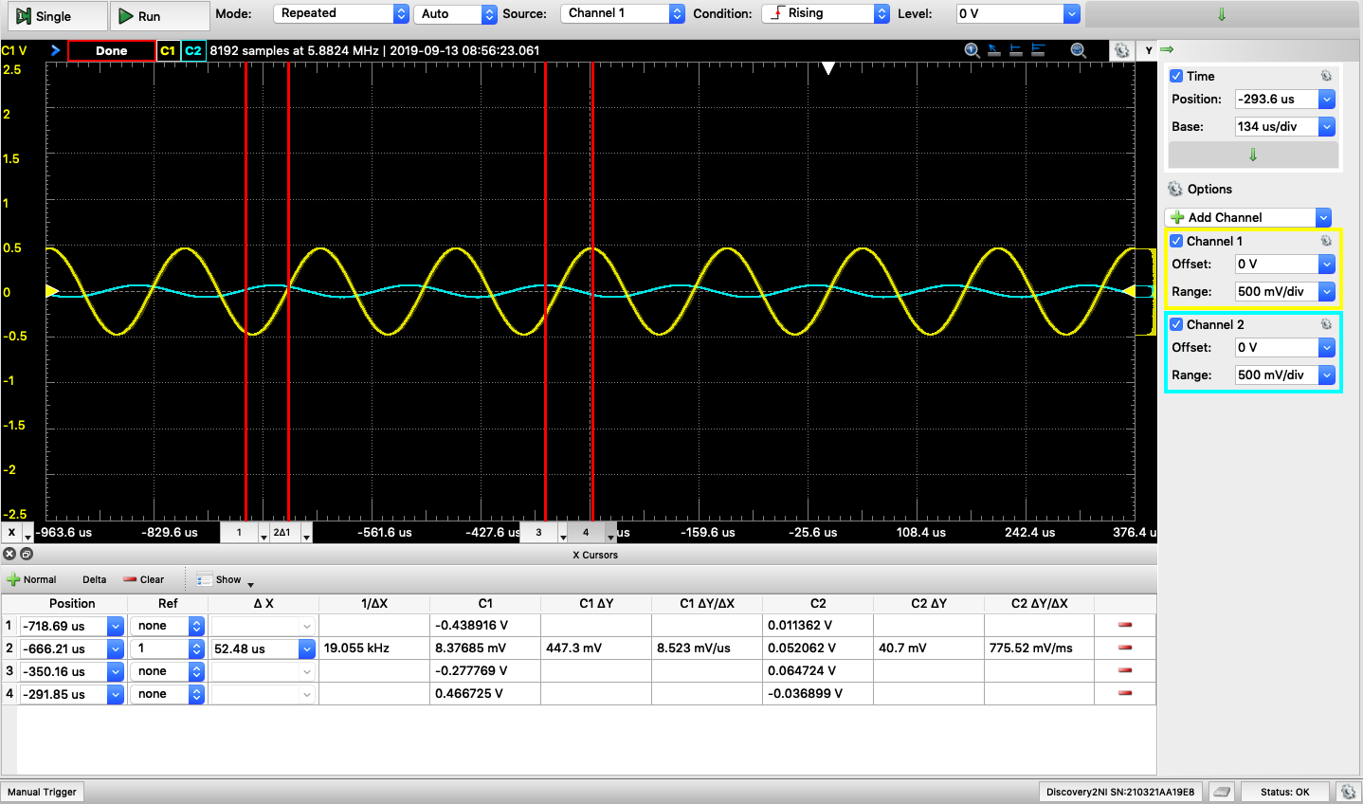

**Circuit c.**

**Circuit c – Bode Plot**

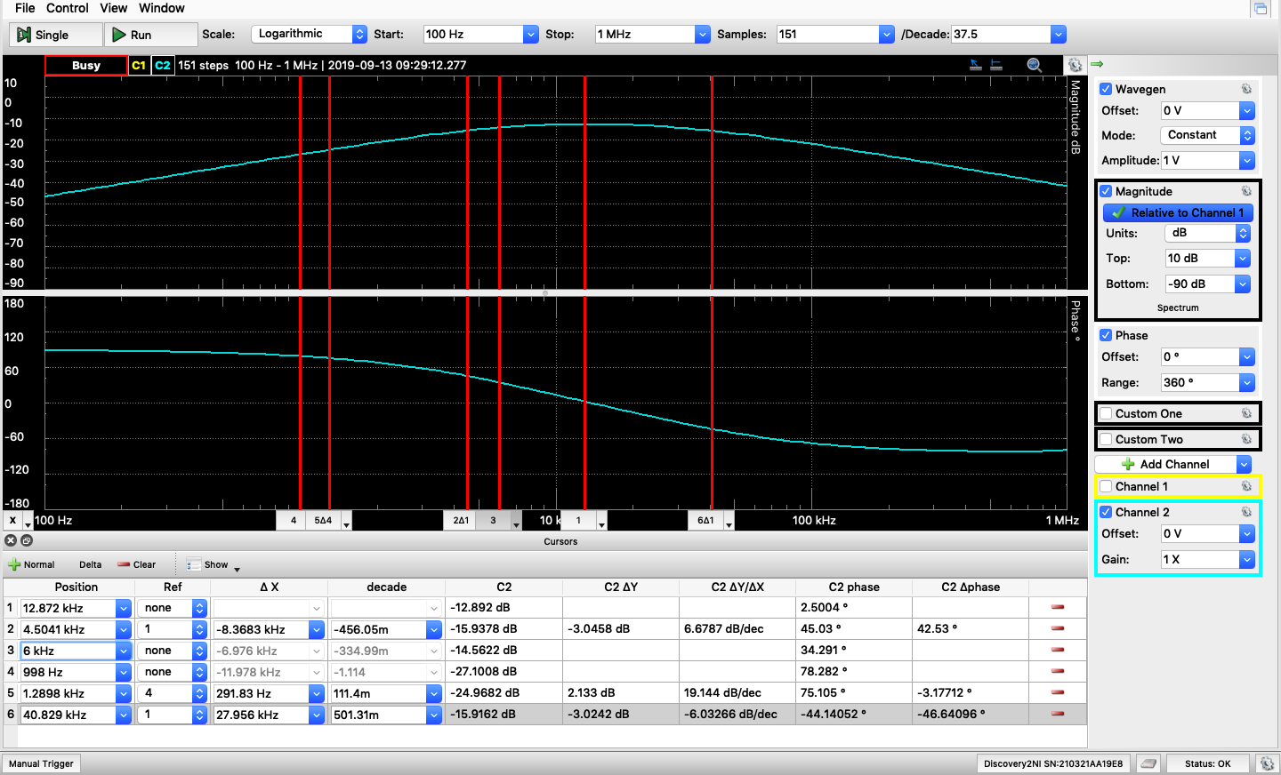

**Circuit c – Time Domain Plot**

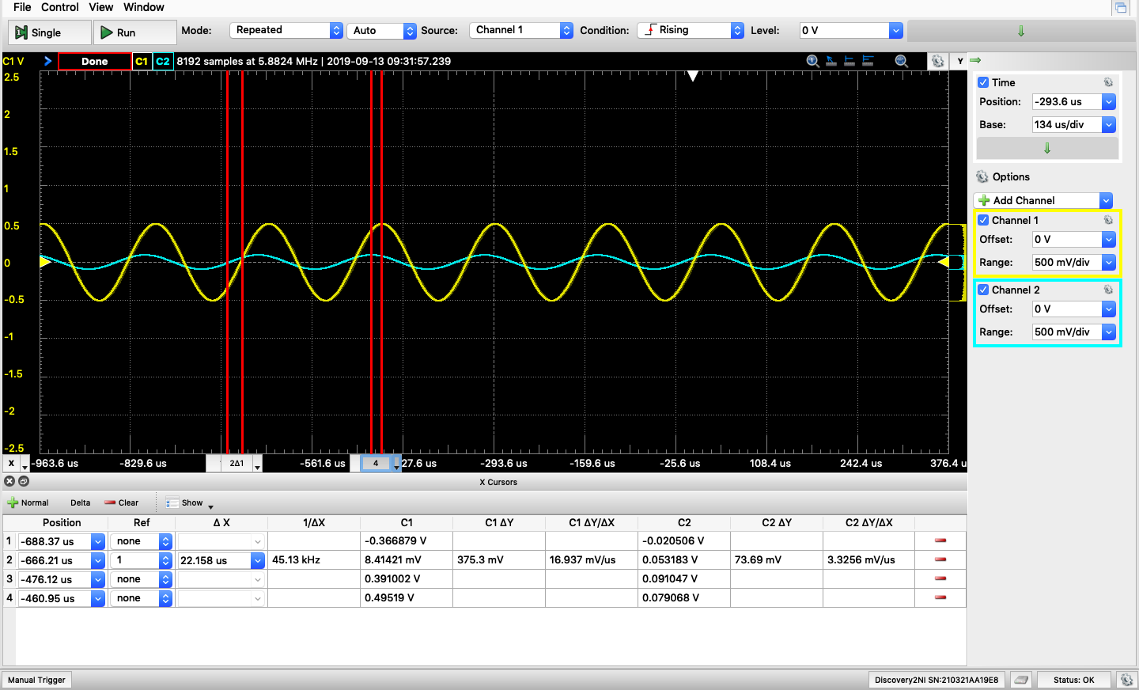

From the measurement plots, we can see that

|  |  |  |  |  |
| --- | --- | --- | --- | --- |
|  | **3-dB Frequency** | **Magnitude @ 6kHz** | **Phase @ 6kHz** | **40dB/dec** |
| **Circuit A** | 5.8kHz | -3.13 dB | -55.2° | 15.3 kHz |
| **Circuit B** | 26.9kHz | -15.6 dB | 119.4° | 1.63 kHz |
| **Circuit C** | 4.5 & 40.8kHz | -14.6 dB | 34.3° |  |

**Table**

For frequency = 6kHz

|  |  |  |  |  |  |
| --- | --- | --- | --- | --- | --- |
|  | **Time Diff. (us)** | **Calculate ∠H** | **Measure**  **∠H** | **Calculate |H|** | **Measure**  **|H|** |
| **Calculation Circuit A** |  | -20.2 |  | 0.483 |  |
| **Calculation Circuit B** |  | 159.7 |  | 0.0137 |  |
| **Calculation Circuit C** |  | 69.7 |  | 0.115 |  |
| **Simulation Circuit A** | 2.14 | 2.14e-6*6k*360 = **4.62°** | -92.4**°** | 0.632/23.5 = 0.027 | -10dB  = 10^(-10/20) = **0.316** |
| **Simulation Circuit B** | -13.0 | -13e-6*6k*360 = -**28.08°** | 87.3**°** | 0.021/650  = 0.000032 | -8.8dB  = 10^(-8.8/20) = **0.36** |
| **Simulation Circuit C** | -8.78 | -8.78e-6*6k*360 = **18.96°** | -2.7**°** | 0.021/135  = 0.000156 | -6.5dB  = 10^(-6.5/20) = **0.473** |
| **Measurement Circuit A** | 54.8 | 54.8e-6*6k*360 = **118.4°** | -55.2**°** | 0.344/0.492 = **0.699** | -3.13dB = 10^(-3.13/20) = **0.697** |
| **Measurement Circuit B** | 52.5 | 52.5e-6*6k*360 = **113.4°** | 119.4**°** | 0.065/0.467 = **0.14** | -15.65dB = 10^(-15.65/20) = **0.165** |
| **Measurement Circuit C** | 22.1 | 22.1e-6*6k*360 = **47.7°** | 34.3**°** | 0.091/0.495 = **0.184** | -14.56dB = 10^(-14.56/20) = **0.187** |

**Comment**

In the lab manual, the frequency given to compute the transfer functions are 4kHz and 8kHz. 4kHz and 8kHz are not separate at lease 1 decade. Therefore, the 2nd part of the circuit would load from 1st part of the circuit. That is the reason why in the measurement, the 3dB frequency is not around 4kHz. It would be a little bit off because of the load from 2nd part of the circuit.